Domain Models

# 

# 

# 

# 

# 

# 

# 

# 

# 

# 

# 

# 

# 

# 

# 

# 

# 

# 1. Domain Conceptual Model

# 

# Buy flowers

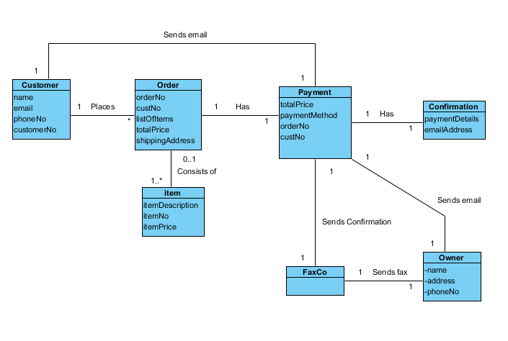

Update/Insert/Delete

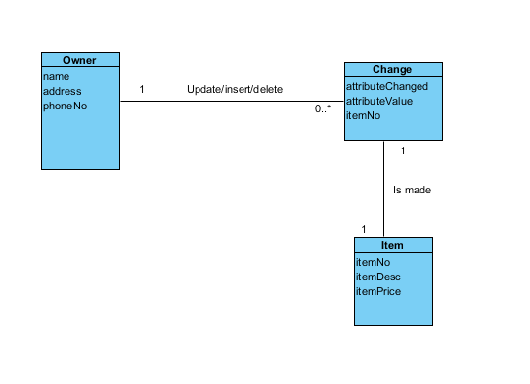

# Domain model

